**Christina Nzekwe**

**Data Analytics BootCamp**

**Conclusions for Crowdfunding Campaigns**

Based on the data provided for crowdfunding campaigns, backers heavily supported theater, film & video, music, and technology. All four had the highest number of campaigns which may have impacted the number of successes. The popularity of theater, film & video and music are sources of entertainment that many people chose to enjoy which may influence backers to support. Plays, rock, web and documentary were the most popular sub-categories among backers. Despite the success among the four categories their failures were among the highest. Journalism was the only category that did not have any failures. Food, games, and publishing had 35% or more failures among their total projects. July, June, March and January had the highest number of successful campaigns. January, August, May and March also had the highest number of failures. The data based on months seem to represent campaigns initiated at the beginning of a new season witness better success.

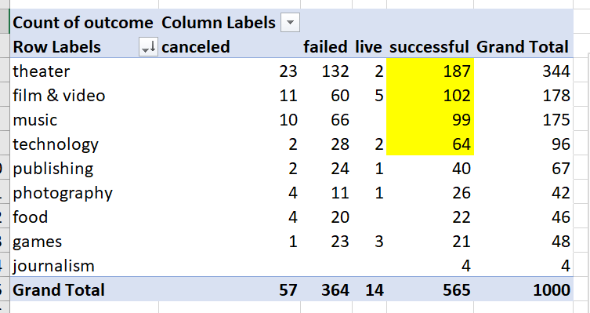**Top Four Success by Category (yellow highlight)**

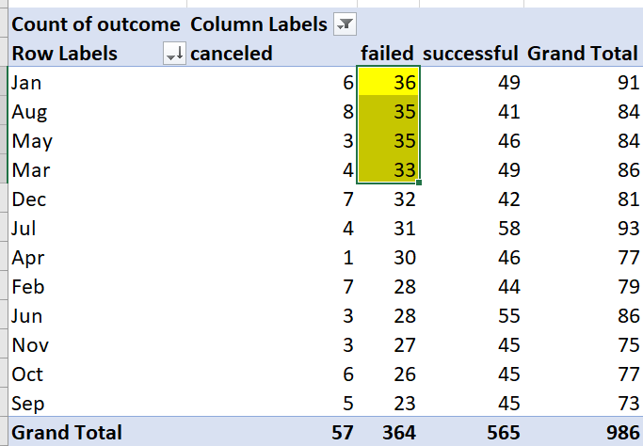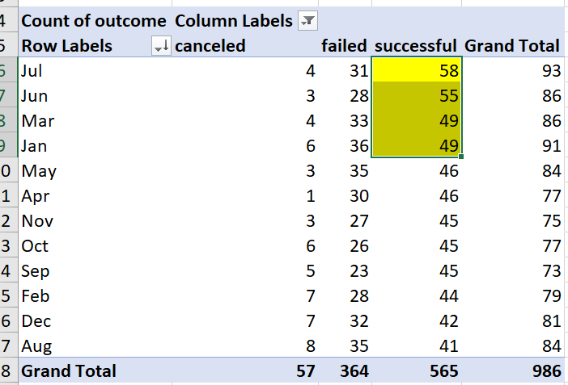**Top Four Success By Month (yellow highlight) Top Four Failures By Month (yellow highlight)**

**Dataset Limitations**

* The data did not provide the pledge amount each backer donated to the campaigns. Knowing how much each backer donated could provide information on whether they supported similar campaigns and pledged similar amounts of money.
* How relevant are the companies involved in conducting the campaigns? Are the companies connected to a fortune 500 or are they established companies? How many times have they conducted a campaign? Understanding the nature of the company may have impacted the success or failures of the campaigns.
* Why are there so many US companies compared to other countries. Is it that US companies have more crowdfunding companies than any other country? Are all companies listed only do crowdfunding or do they have additional business ventures they provide to the public?

**Possible Tables and Graphs for Crowdfunding Campaigns**

* The number of campaigns per company and look at which category received the most money. This could give insight into which category is most popular for the company.
* The amount of money each backer based on the campaigns. Are backers pledging with new companies or more established companies? Do specific backers like to give more money to one category over another?
* Graph on how long did the pledge last for success, failures, and canceled campaigns. Provides information on how quickly companies were able to meet their pledge. Did it take days, weeks, or months? Also, may show how popular the campaigns are.